Sprint 3 Plan
“Expiry Logic”

SlugIn

Aashna Shimkhada, Christina Chan, Erika Wu, Jetha Mot, Sara Srivastava, Sharon Akkara
Sprint Completion Date: November 18th, 2025
Revision 2: November 5th, 2025
Goal: To allow faculty and student leaders to post opportunities. To allow students to access and view these opportunities in a feed, save opportunities, and mark opportunities as applied.
Task listing, organized by user story:
User Story 3.1: (“As a student, I want to see up-to-date opportunities by seeing out-of-date ones get taken down, so I save time applying to open ones.”) (5 points)
- Task 1: Add Status Property to Opportunities in DB (based on date values) (1)
- Task 2: Add Status Property view to opportunity card (for user view) (2)
- Task 3: Add logic to hide opportunity if passed “expiry date” (2)
  - Change Status Property to Active to Archived if the date is before the current date.
  - Code it so that Active events will show up on the opportunities page, but archived events will not.

User Story 3.2: (“As a student, I want to sort the listings by the date added or by the date the listing closes so I can prioritize applications.”) (7 points)
- Task 1: On the /opportunities page, on the top, create a drop down button for filters (3)
  - Filters should include:
    - Most recently posted (Default)
    - Oldest Posting
    - By latest closing/expiry date
    - The soonest closing/expiry date
- Task 2: Based on filter, sort order opportunities cards are presented accordingly (4)

User Story 3.3: (“As a club owner/professor, I want to receive an email or dashboard alert before my opportunity expires, so I can renew or update the listing if it is still open.”) (10 points)
- Task 1: Use supabase to create an email system to alert all posters five days before their opportunity expires, stating “Your opportunity is about to expire.. Click here to edit” (5)
- Task 2: The click here to edit will be a link back to the posts branch where the previous information is pre-saved and the poster can edit (5)
  - Render the posting page with the post's information
  - Allow users to edit and post again/update their post.
    - Change post button → update button
Team roles:
Aashna Shimkhada - Developer
Christina Chan - Product Owner, Developer
Erika Wu - Scrum Master
Jetha Mot - Developer
Sara Srivastava - Developer
Sharon Akkara - Developer

Initial task assignment:
Aashna Shimkhada - US 3.3 Task 1
Christina Chan - US 3.3 Task 2
Erika Wu - US 3.2
Jetha Mot - US 3.1
Sara Srivastava - US 3.1
Sharon Akkara - US 3.2
Initial burnup chart: A graph giving the initial burnup chart for this sprint and is labeled as such with sprint number and project name and is located in the lab.
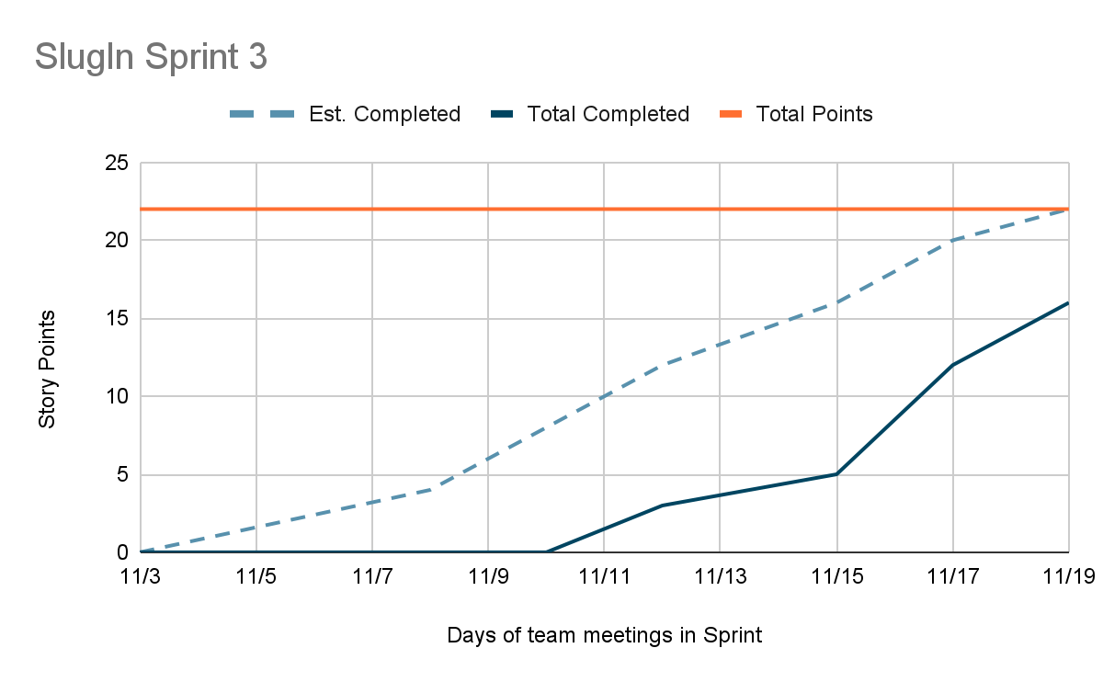
Initial scrum board: Also known as a task board, the scrum board is a physical board and labeled as such with sprint number and project name and located in the lab. This board has four columns, titled user stories, tasks not started, tasks in progress, and tasks completed. Index cards or post-it notes representing the user stories and the tasks for this sprint should be placed in the user stories, tasks not started, and tasks in progress columns. Tasks associated with a user story should be placed in the same row as the user story.

User story | Task | In progress | complete | Story points
User Story 3.1 | Task 1
 | Task 2 | X - Jetha 11/12 | X- Jetha 11/13 | 2
 | Task 3 | X - Sara  11/13 | X - Sara  11/17 | 2
User Story 3.2 | Task 1 | X - Erika 11/9  X - Sharon 11/11 | X - Erika 11/12  X - Sharon 11/12 | 3
 | Task 2 | X - Erika 11/12  X - Sharon 11/12 | X - Erika 11/18  X - Sharon 11/18 | 4
User Story 3.3 | Task 1 | X - Aashna 11/12
 | Task 2 | X - Christina 11/12 | X - Christina  11/17 | 5

Scrum times: List at least the three days and times during the week when your team will meet and conduct Scrum meetings. Also, indicate which of these meetings will have the TA/tutor visit as arranged with the TA/tutor. It is expected the TA/tutor will visit during the Scrum meeting during your lab time.

Times meeting:
- Friday 1:30 pm -2 pm
- Wednesday 1:30 pm - 2 pm
- Monday 1:30 pm - 2 pm
Meeting with TA:
- Wednesday 4:30 pm - 5:15 pm

